Chapter 10, Problem 77.

Compute the closed-loop gain V_{o}/V_{s} for the op amp circuit of Fig. 10.120.

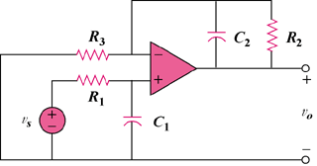

Figure 10.120
For Prob. 10.77.

